Security Risk Assessment Playbook
Azure VM & Microsoft Defender for Cloud
Demonstration Portfolio Piece
Author: Wachiraya Meevasana (Tanny)
Date: August 11, 2025

Executive Summary
This playbook documents a controlled security assessment of an Azure-hosted Ubuntu Linux VM using Microsoft Defender for Cloud. The objective was to simulate common misconfigurations (open SSH port, weak privileged user, disabled firewall), validate Defender's detection capabilities, map findings to compliance frameworks (CIS, NIST), and execute remediation steps. The deliverable is intended as a demonstration of security risk assessment skills in a cloud environment.

Purpose
Guide security teams in detecting, validating, and remediating open network ports and weak configurations in Azure-hosted Linux VMs using Microsoft Defender for Cloud.

Scope
Applicable to all Linux VMs in Azure environments, across test, staging, and production systems, particularly where SSH or privileged accounts are in use.

Risk Assessment Overview
Finding | Likelihood | Impact | Risk Rating
SSH open to 0.0.0.0/0 | High | High | Critical
Weak privileged user credentials | High | High | Critical
Firewall disabled | High | Medium | High

Playbook Steps

Intake & Asset Identification
- 1. Log VM details (OS, IP, hostname).
- 2. Record baseline Secure Score in Microsoft Defender for Cloud.
- 3. Assign a Risk Owner for the assessment.

Threat Simulation
- 1. SSH into the VM from an external IP.
- 2. Create privileged weak user (testuser:test).
- 3. Disable UFW firewall.
- 4. Configure NSG to allow SSH from 0.0.0.0/0.
- 5. Optional: Run Nmap scan to simulate external probing.

Detection & Alert Verification
- 1. Monitor Defender for Cloud alerts for SSH exposure, weak credentials, and disabled firewall.
- 2. Validate severity ratings and recommended remediation steps.

Control & Gap Analysis
- 1. Map findings to CIS Benchmarks and NIST 800-53 controls.
- 2. Assign Risk Score based on Likelihood × Impact.

Risk Treatment & Remediation
- 1. Restrict SSH to specific IP ranges.
- 2. Remove weak privileged accounts.
- 3. Enable UFW firewall with default deny rules.
- 4. Deploy endpoint protection agent.

Documentation & Reporting
- 1. Capture before/after Secure Score screenshots.
- 2. Document actions in Risk Register.
- 3. Generate a final Security Assessment Report.

Continuous Monitoring
- 1. Schedule Defender for Cloud scans.
- 2. Automate alert ingestion into SIEM.
- 3. Track KPI trends (TTD, TTR, SLA compliance).

Evidence & Screenshots
Figure 1: SSH Port Exposed - Connection from external IP with unrestricted SSH access.
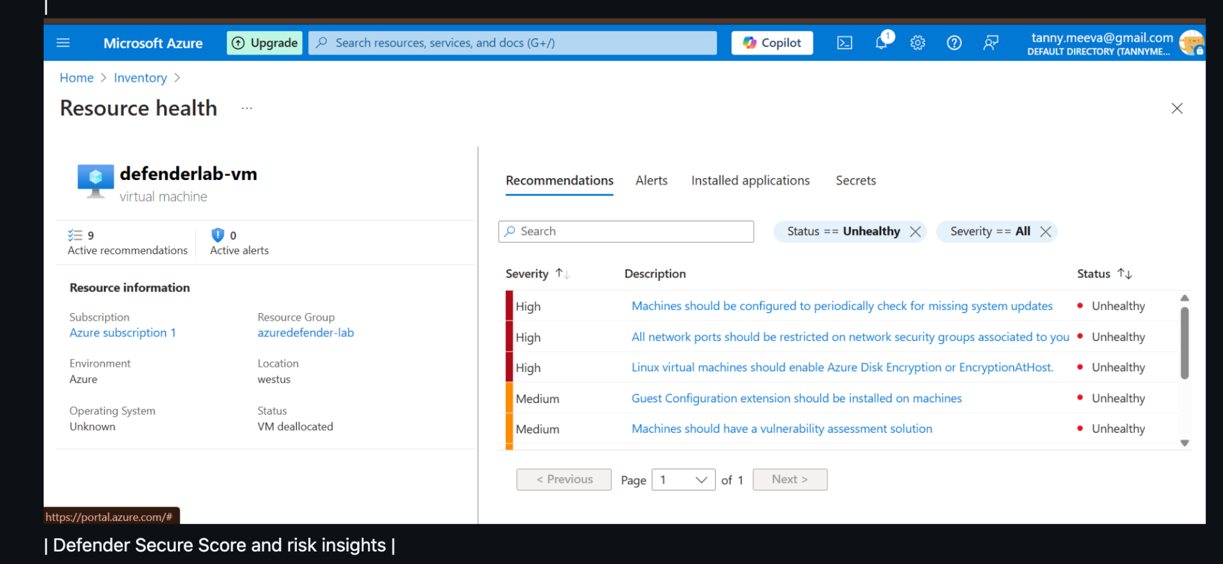
Figure 2: Weak privileged user 'testuser' creation and firewall (UFW) disabled.
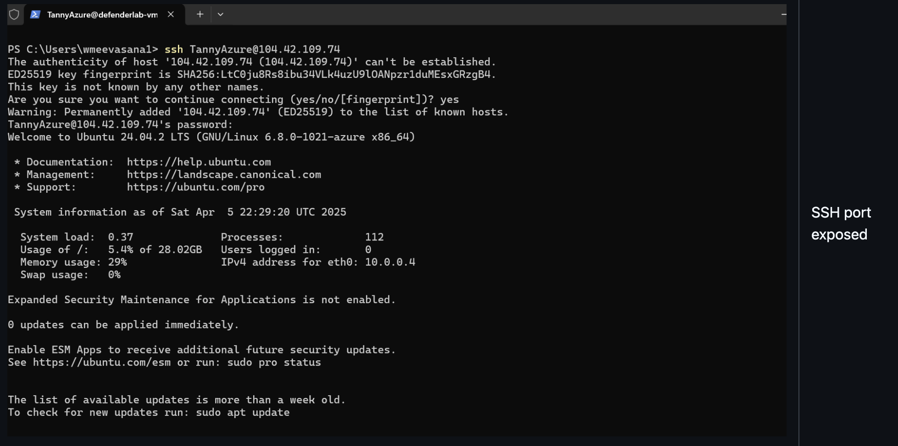

Key Takeaways
- Defender for Cloud effectively detects misconfigurations including open ports, weak accounts, and disabled firewalls.
- Risk scoring aligns with CIS/NIST control mapping for compliance readiness.
- Structured remediation and continuous monitoring are critical to reducing exposure windows.

